- Step 1: Install and Configure Minikube and KServe
- Install Minikube: Make sure you have a compatible version of VirtualBox or Hyper-V installed. Then download the Minikube installer.
- Start Minikube: Open PowerShell and start Minikube with the following command:
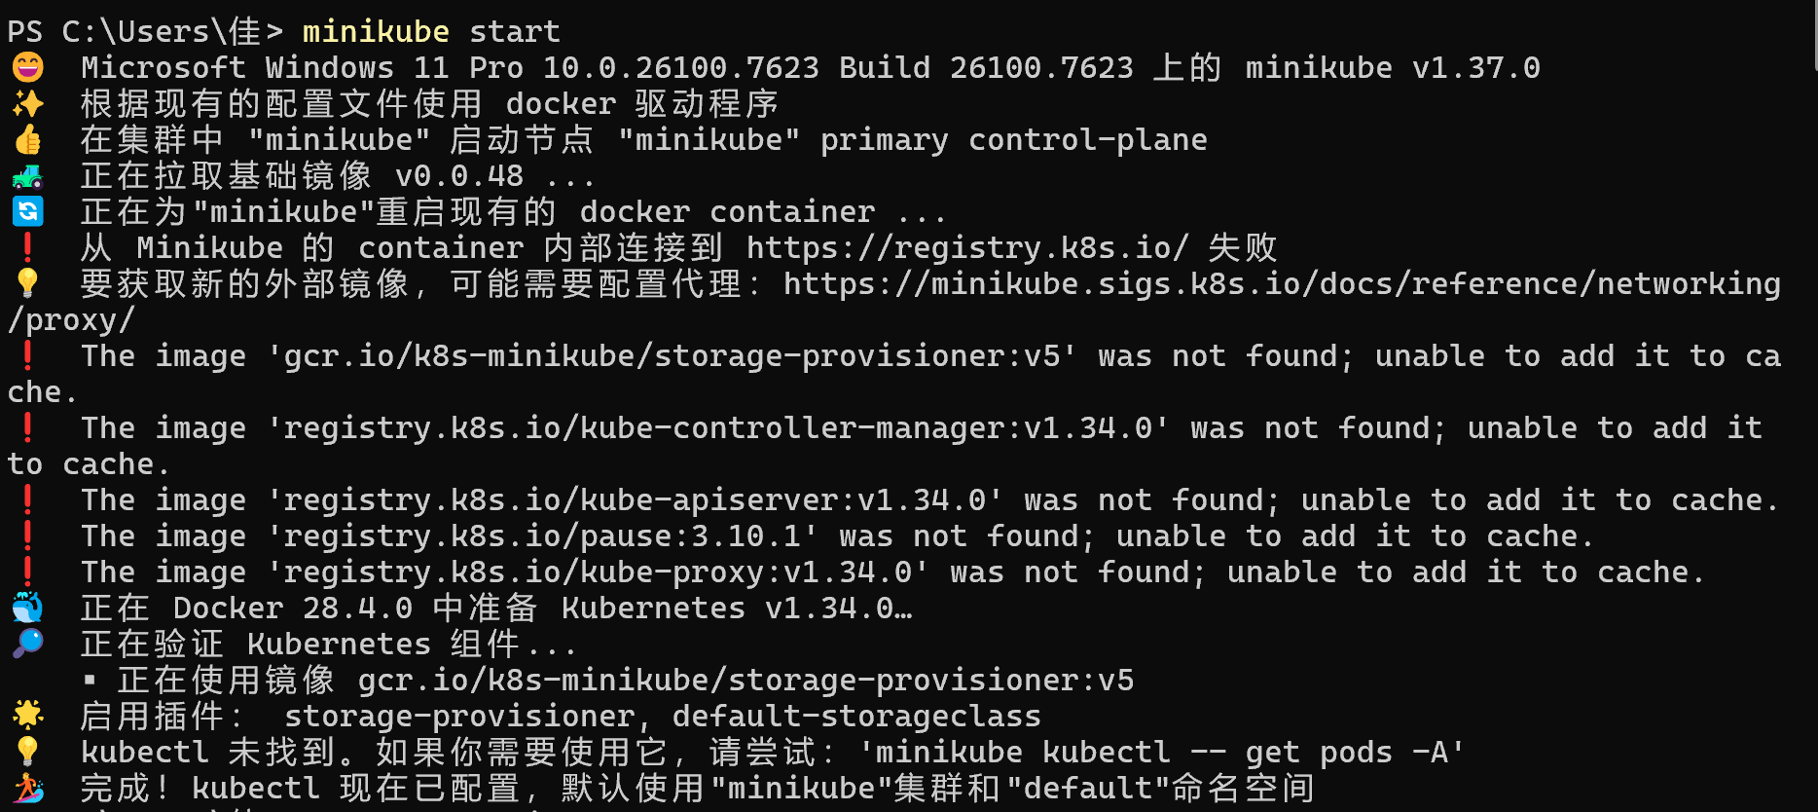
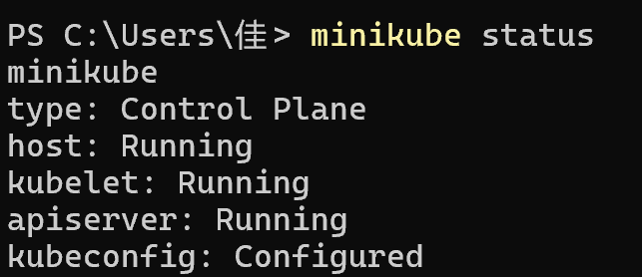
- Enable Ingress: KServe requires an ingress controller to handle external requests.
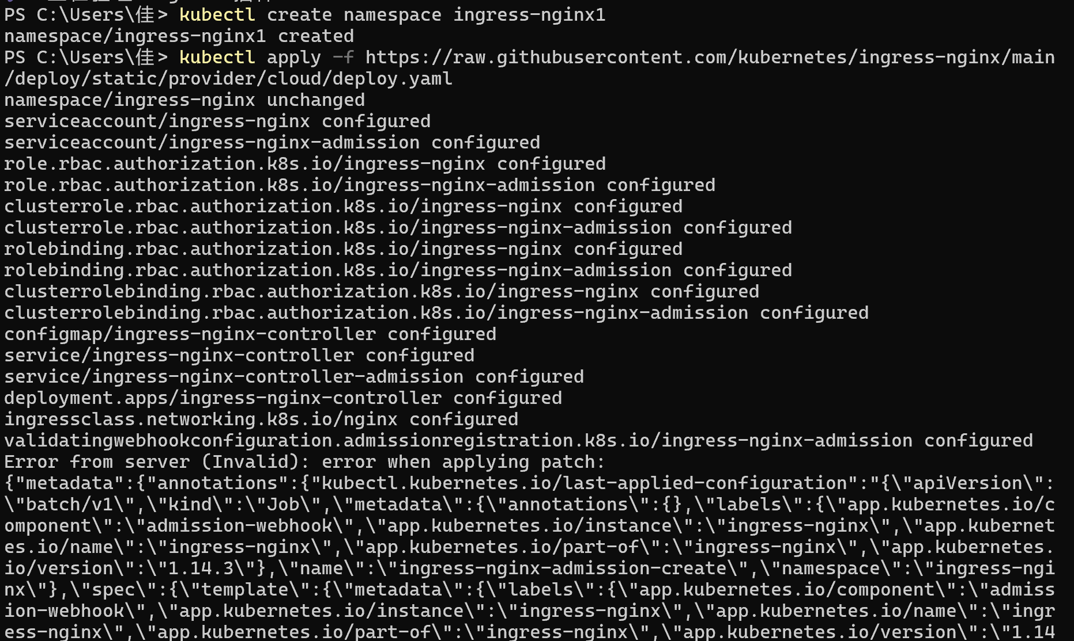
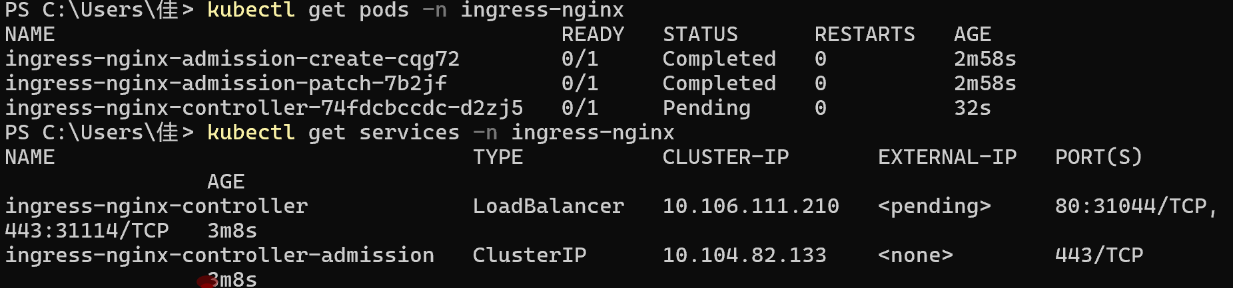
- Install KServe: Apply KServe manifests to your cluster.
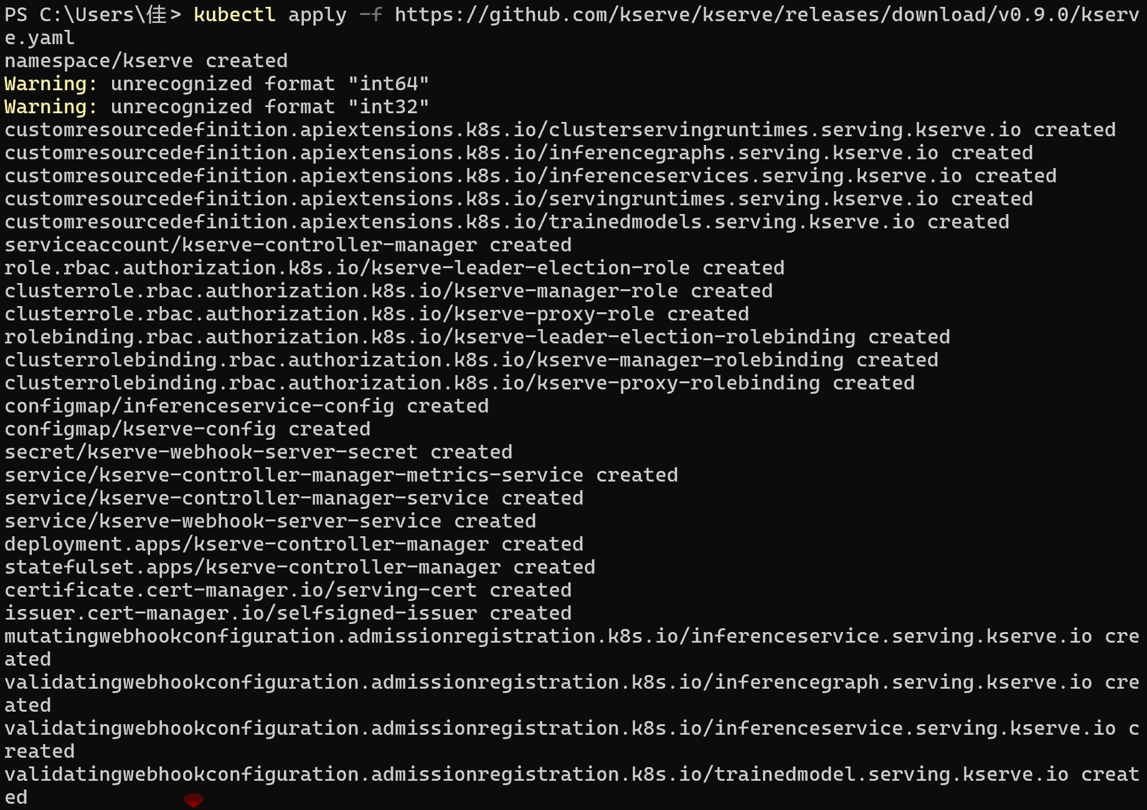
- Verify KServe Installation: Check if KServe components are running.
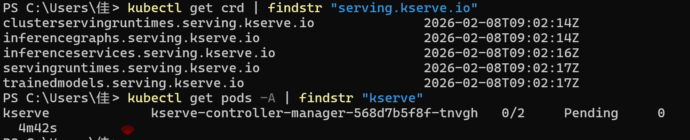
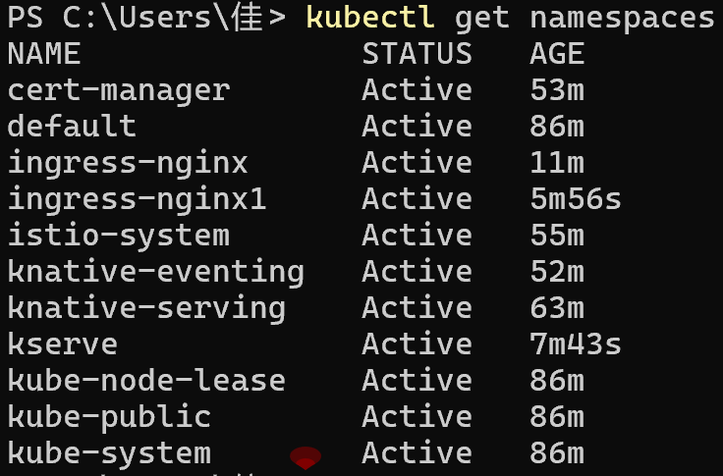
- Step 2: Deploy a Predictive Model Using KServe InferenceService
- Choose a Predictive Model: For this example, let’s deploy a simple Scikit-learn model (e.g., Iris classification).
- Create a Model Service YAML file: Create a file named with the following content:
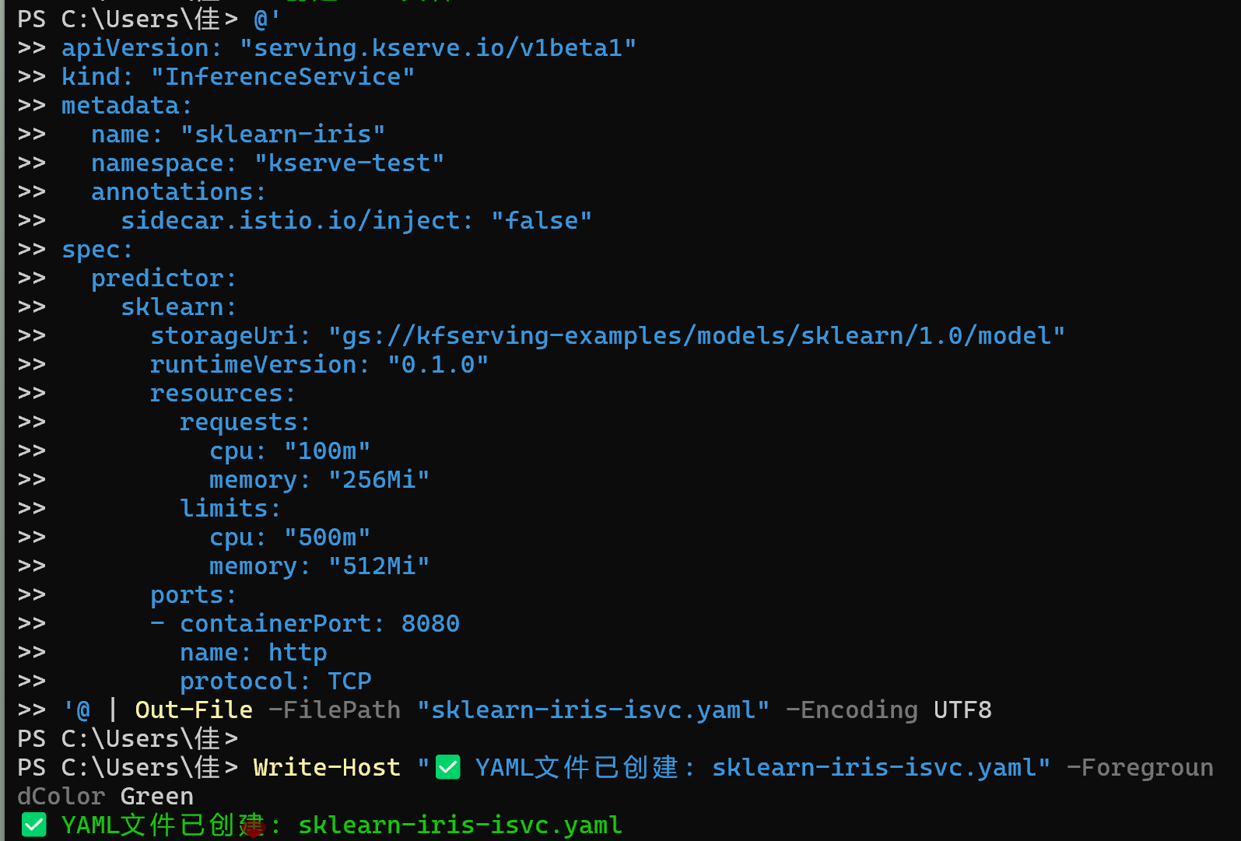
- Deploy the Model&Check the Deployment Status：
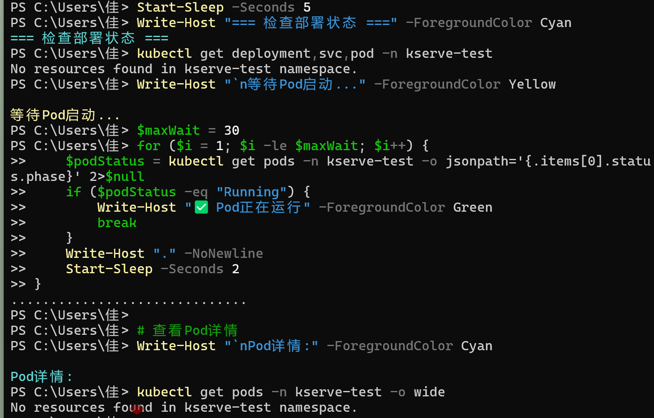

- Step 3: Enable port forwarding
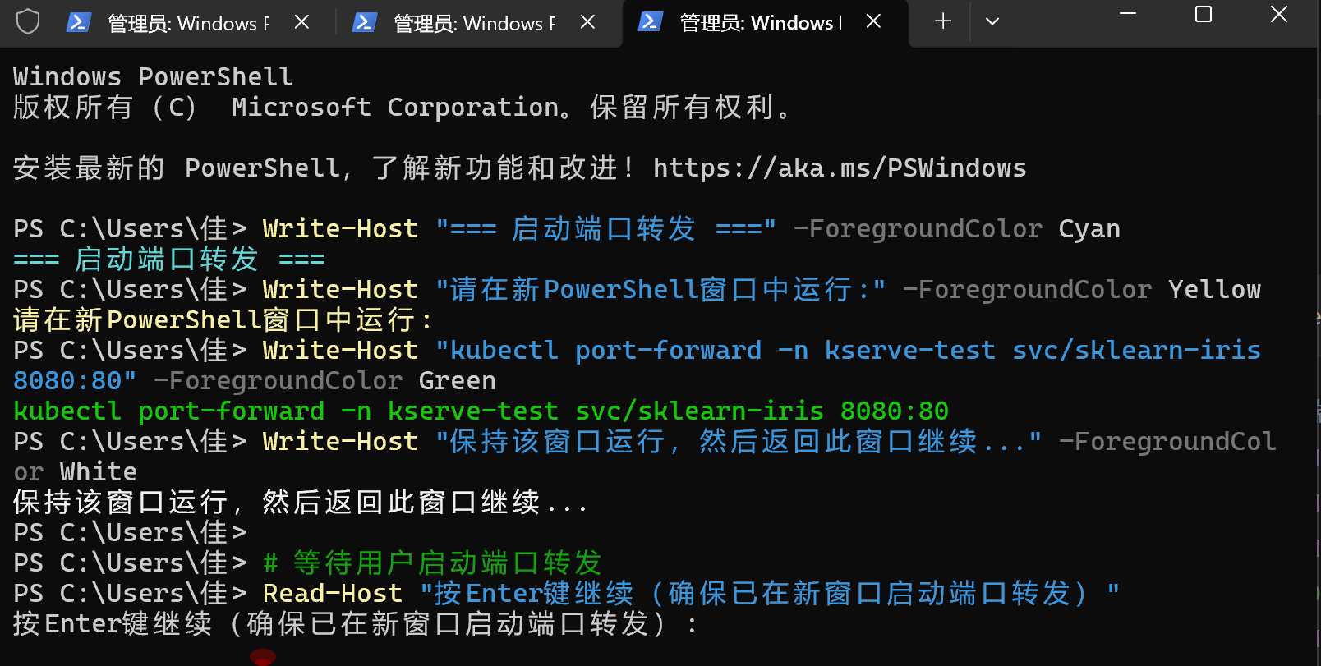
- Step 4: Test the connection and send an inference request
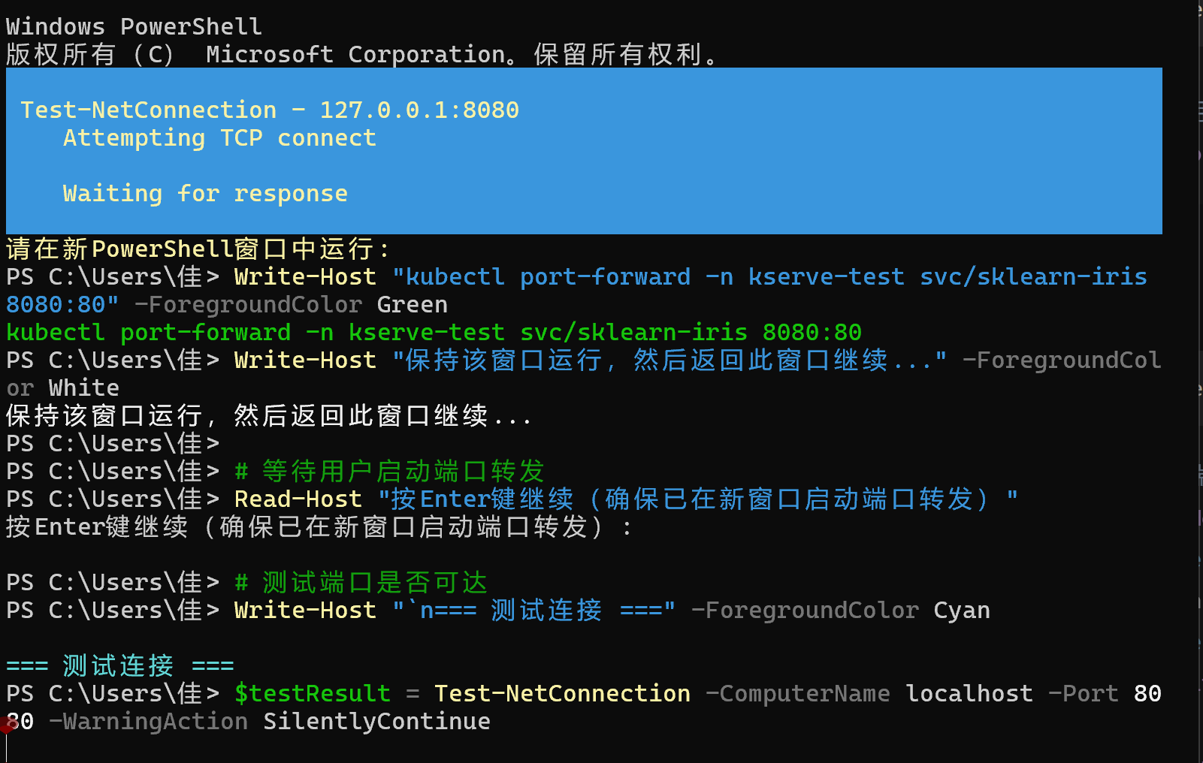
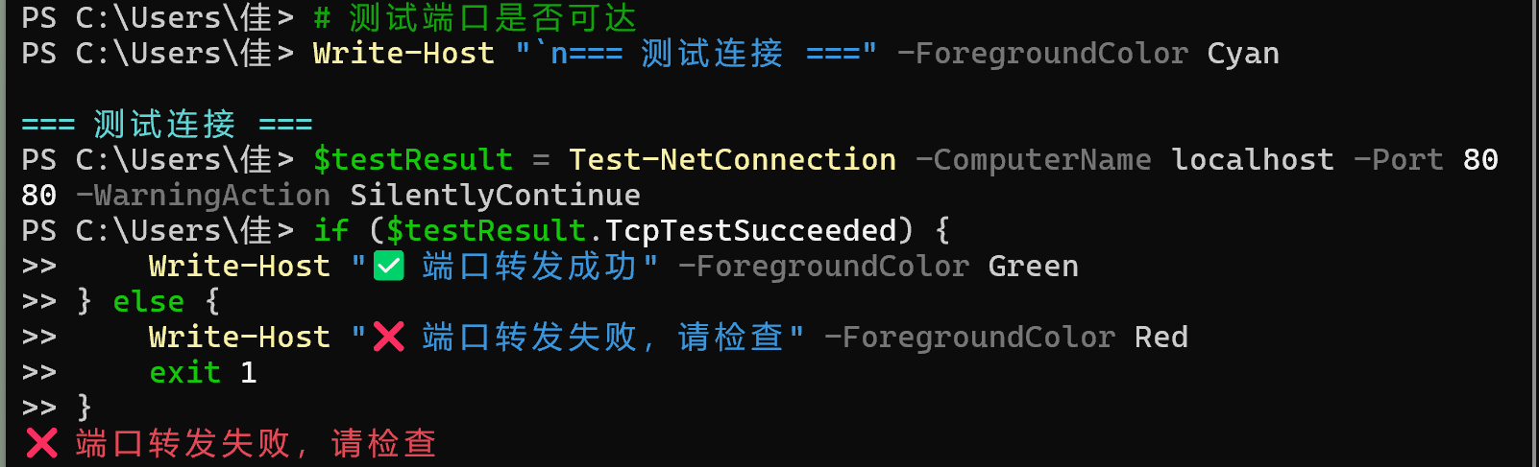
- Step 5: Send Inference Requests and Interpret Results
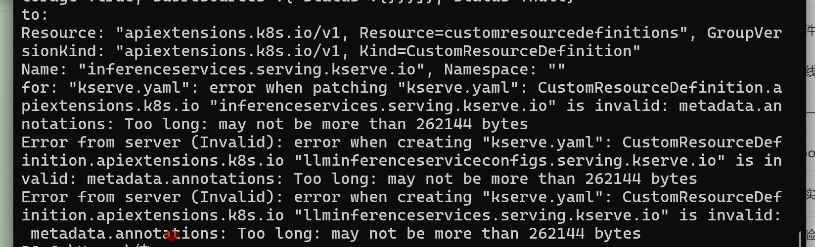

Final method:deploy pod model
- Create a namespace
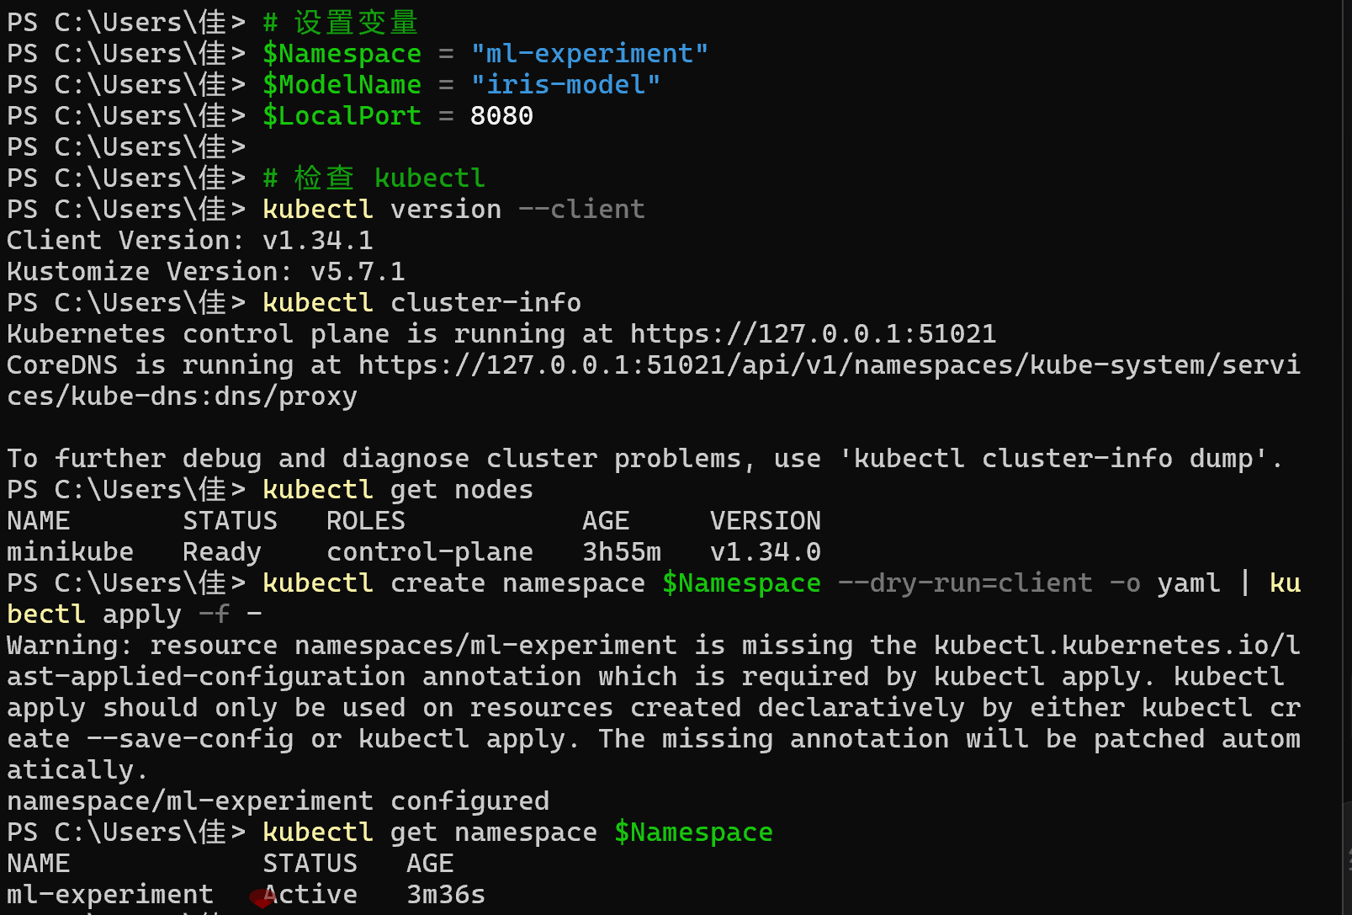

- Deploy the model pod
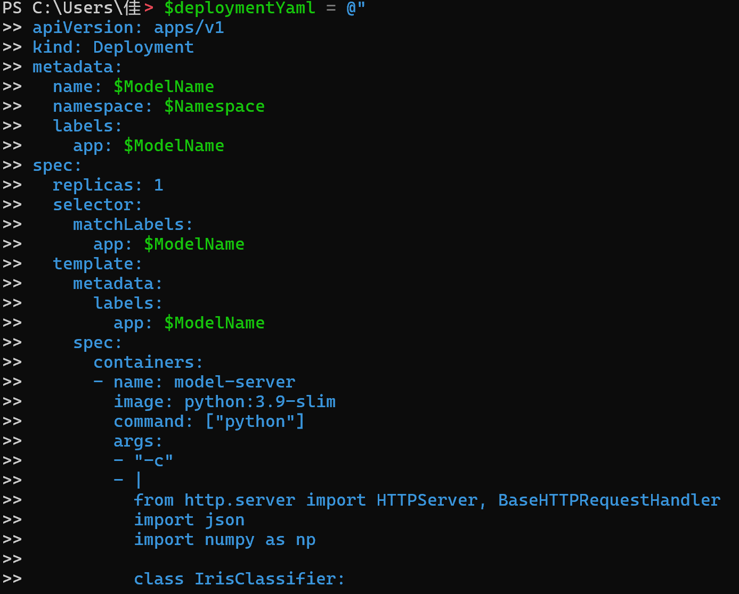
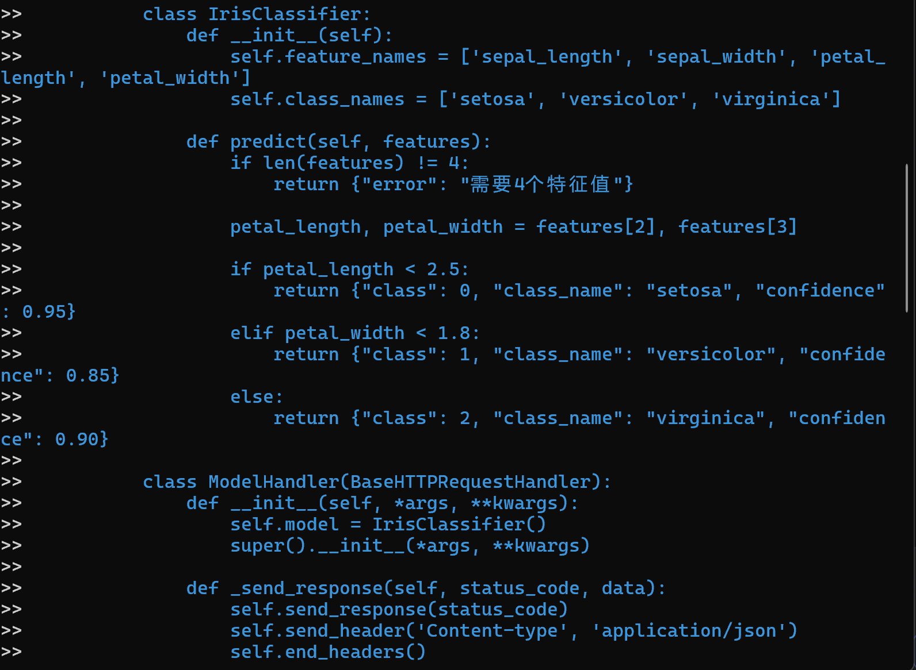
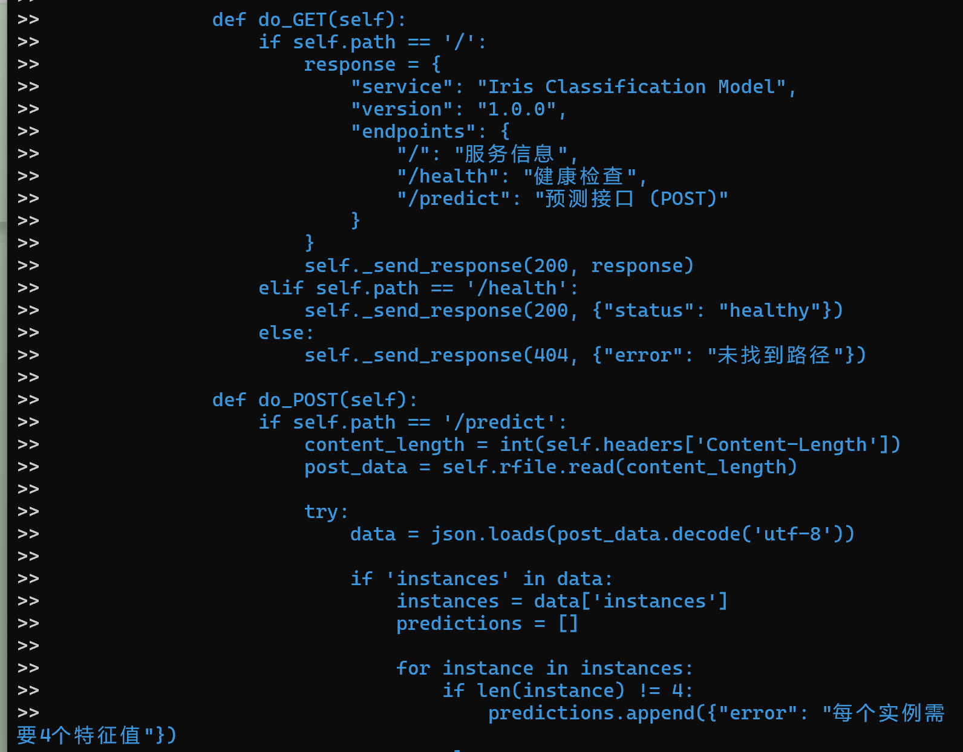
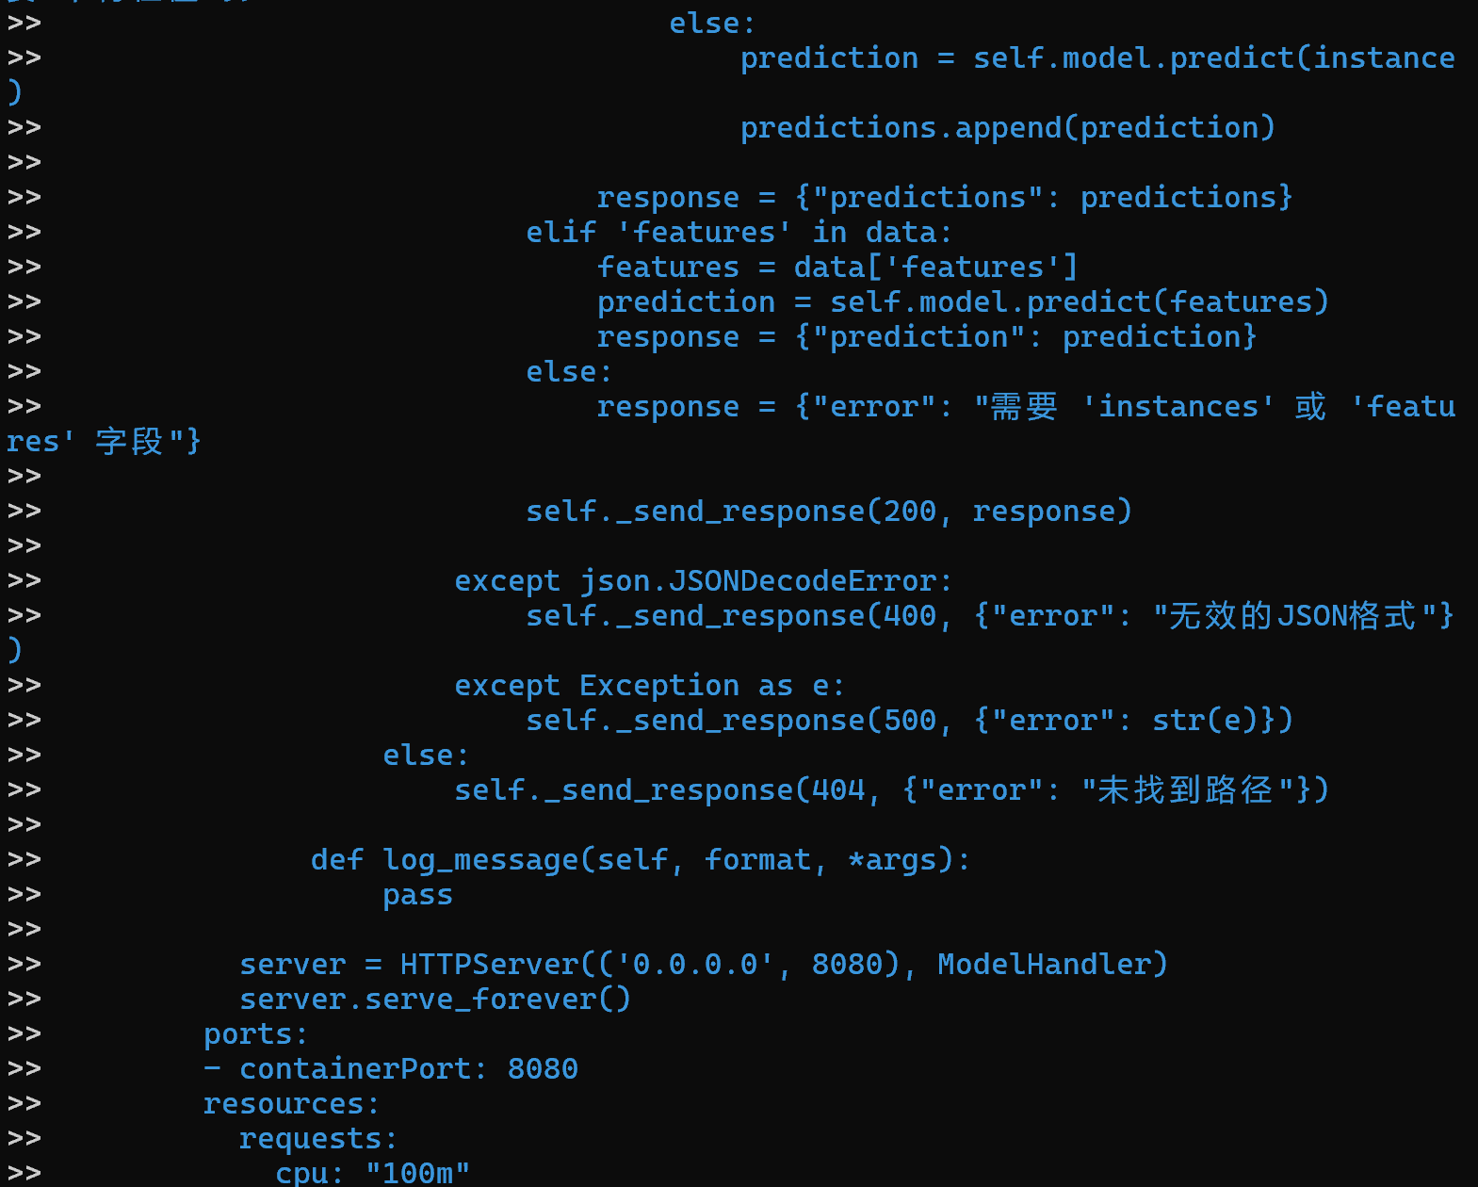
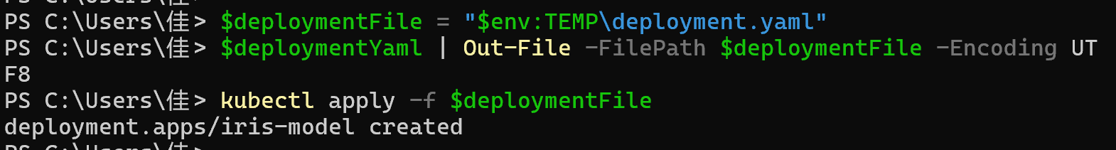

- Create a service
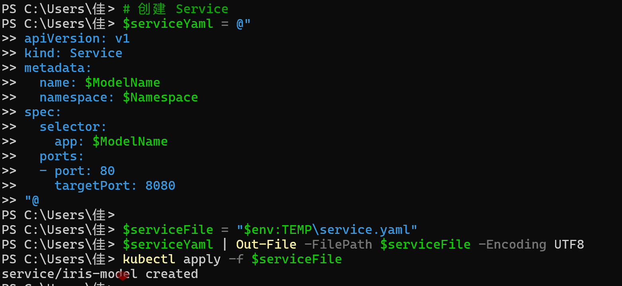
- Check status
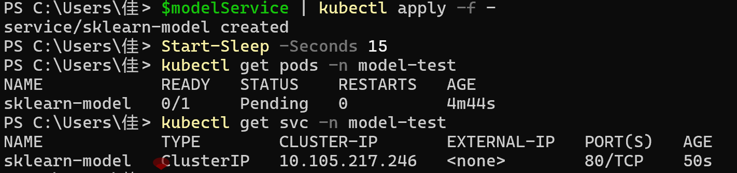
- Port forwarding and testing
